USER GUIDE

Change password

September 2018

Version 1.01

Pharmacon ITC303/309 Group

Document Revisions

|  |  |  |
| --- | --- | --- |
| Date | Version Number | Document Changes |
| 14/09/2018 | 1.01 | Initial |
|  |  |  |
|  |  |  |
|  |  |  |
|  |  |  |
|  |  |  |
|  |  |  |
|  |  |  |
|  |  |  |

Table of Contents

1 Introduction 4

1.1 Scope and Purpose 4

1.2 Process Overview 4

2 Change password 6

2.1 Locate User (login) 6

2.1.1 Load Change Password Form: 6

2.1.2 Change Password Form: 7

# Introduction

## Scope and Purpose

The purpose of this user guide is to provide instructions on how to change the password for a user (login). No other features of the Pharmacy Error Tracker (PET) application will be discussed in this user guide.

* To be able to use PET, the user will need basic knowledge of logging into an online application and using a search function to locate records.
* This feature is only available to a user with administrator rights.

## Process Overview

The administrator will need to log into PET using their valid username and password.

* The Welcome Page will be presented on successful login.
* The administrator will need to select Change password via the menu bar or the button on the menu page.

The administrator will need to know the user’s login or part thereof for search purposes.

Login screen when PET is launched

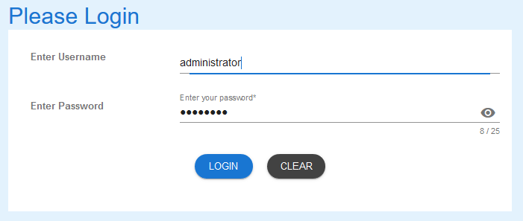

Welcome Page on successful login

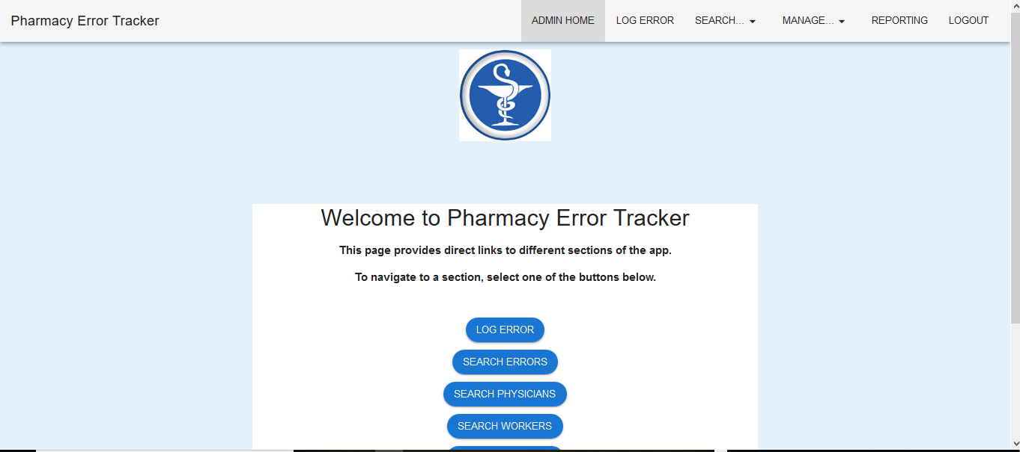

# Change password

To search for a user, the administrator will need to launch the application, login with a valid user name and password with administration rights. Using the search function, the administrator will be able locate a user (login) relating to the search criteria entered and be able to change the password.

## Locate User (login)

Administrator must have located the required user via the Search Users function.

### Load Change Password Form:

1. Select “Change Password” button.

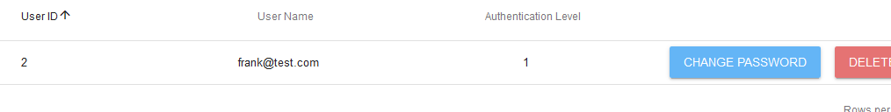

1. Change password form will load.

### Change Password Form:

Click in the “Password” field and enter a new password.

1. Password must be a minimum of 8 alpha/numerical characters with a maximum of 25.

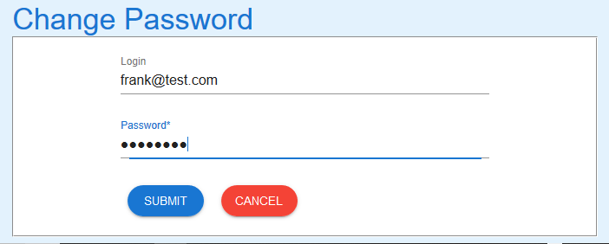

1. “Submit” button to update password for the user. Message that password was successfully update appears and then search screen reappears.

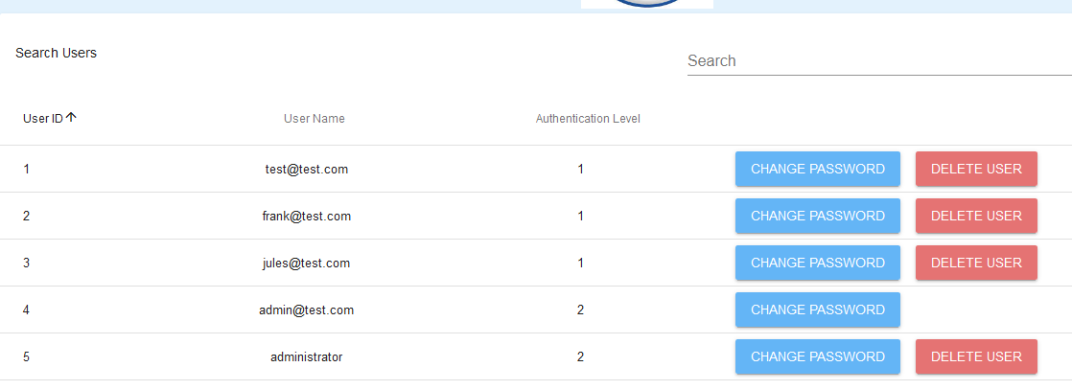

If you encounter issues not addressed by this user guide, please contact your account manager for additional support.